
CS 319 - Object-Oriented Software Engineering
Analysis Report
Where is My Ring
Group 1-C
Hamza Akhbar
Emre Dikeneli
Bahadır Durmaz
Ali Soyaslan
- Introduction
“Where’s My Ring” is an Android application we plan to design for Bilkent University students. Its primary purpose is to tell students in real-time where each Bilkent University’s bus is at the time. This information given to the student using the app will be in the form of a map that will show the location of each bus, and the time it will take a particular bus to reach the student’s location. We chose this app because of late there have been discrepancies in the buses’ stated arrival times and their actual arrival times due to a number of factors. By making this app, we hope to alleviate the problem, if not completely eradicate.
- Overview
The app “Where’s My Ring” will make use of three technologies: one, Android library on Android Studio IDE; two, PHP for server-side scripting on CLOUD9 IDE; three, MySQL for database management. We plan to use a remote server, but if that’s not possible, we will establish the server on our own computer, which will serve as both the server and the client.
“Where’s My Ring” will be quite a simple app, as it will only locate all the buses on a map, or if a student will want to know the arrival time of a bus, then the app will ask the student’s current location and where the student wants to go in the form of 5 options: “Nizamiye”; “Tunus”; “Sihiyye”; “East Campus”; “Main Campus.” After choosing one of the 5 options, the app will tell how much time it will take until the bus to come to the student’s location.
For tracking the buses, we will need real-time GPS data, and that will be provided to us by the Bilkent University Transportation Department, and we will embed that in our app, and map that data onto a map through Android’s GPS API. The app will only be used by Bilkent University students, as students will have to login with their Bilkent University email id’s.

  - Authentication
Authentication for this app should be precise and private because Bilkent University does not permit other people than its own students to use the services. This process will include entry of the student number and some other personal data that also we can reach but also enough to prove that the applicant is a student in Bilkent University. After the authentication, the user can access any data our application offers.

  - General Map Display
This function is a display of the city map with colored pins on it showing the real-time locations of the buses. Users, whose time schedule is flexible, can use this option to schedule their travels. (i.e. to city, to A.Ş.T.İ) If the user touches on any of the colored pins on the map, a dialog box or a slide window will appear and show the specifications of the bus, driver and remaining time to next stop and final destination.

  - Select Bus
This function is for more tightly scheduled students or exchange students who does not know the city enough. On the main page of this function, there are a few fields to fill. From where, to where. Then the application chooses best bus for you and shows the alternatives for your trip.

  - Bus Types
    - In Campus
In campus buses will probably have a lower usage than off campus ones. Because the maximum waiting time of these buses are 4-6 minutes. This function is good for catching classes in breaks. This function could also be used as an alert mechanism for the rings in the feature.

    - Off Campus
These buses will be the most used buses and the authentication of the driver will be made by the security office on the way out. As the drivers always get off the bus and go to entrance hut for their finger prints to be read. The security will sign the bus up for the trip and our application will get the data from that database.

- Requirement Specifications
  - Functional Requirements
    - Login
The login information is gathered from a database that we are going to form with MySQL. Before the login phase, there should be signup phase for the new users. The access to our database is protected by standard http and the tools we use also gives us some extra functions for protection of data. So, our database will be secure enough against penetration or injections.

    - Signup
This function is a little more detailed. As we have no access to the personal data of students, we have to authenticate the students manually. Although we have not come up with an automated idea, we will ask for one more personal data and check the students ourselves for now. At the publication step of this application, the school management may give us some more information about the student for authentication process.

    - Map Activity
This activity (means page in Android platform) will show the user the map and buses on it with a colored pin. The map will be the system map of Google Maps and the pins on it is supported by the system map itself. The data will be gathered from Bilkent Transportation Unit’s own database and put on the map with a locate function. Users can see all the buses from here and plan their trips. The update speed of GPS data changes in time so the application will send a ping over a fixed period of time, check the changes on database and then update the map accordingly.

    - Bus Selection Activity
The selection of buses is easy enough for everyone to use. User only have to select “from” and “to” of the bus specifications. The application will show the user best bus for the travel and display the alternatives. User’s selection will filter the buses in Android platform and then check the GPS data for time issues.

  - Non-functional Requirements
    - Application Performance
The performance of mobile applications has the highest priority nowadays and we have to implement our application as optimized as we can. We are going to use different tools and packages that frees the memory off some unnecessary data. We have to avoid instant generation of data and store them in a temporary cache so that our application does not affect the refreshment and usage of other background applications.

    - User Friendly Interface
We want our interface to be very simple so our positioning of graphical items must be reachable easily and we plan on using scroll pages at minimal. User should not try to use the application. The application should be familiar at the first glance.
    - Upgradeability
As many other software, our application should be upgraded or patched at some point. So we want our application to be available for extending in any aspect.

- System Model
  - Use Case Diagram
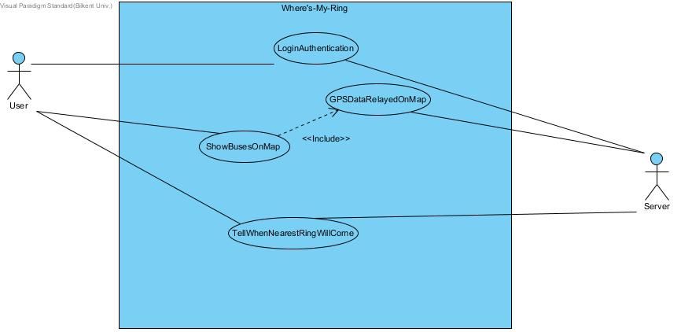
    - Login Authentication
Use Case Name: LoginAuthentication
Participating Actors: User, Server
Flow of Events:
1. The User inputs his Bilkent University email ID and password.
2. The Server checks whether the login information is correct.
3. The User successfully logs in on “Where’s My Ring” if the information is correct. If the information is wrong, the User is denied access.
4. On a successful login, the User is taken to the main screen of the app.
Entry Condition: The User has opened the app on his Android device.
Exit Condition: The User has successfully logged in.
    - Show Busses On Map
Use case name: ShowBusesOnMap
Participating Actors: User, Server
Flow of Events:
1. The User chooses the “Show Rings on Map” option from the app’s main screen.
2. The Server retrieves the GPS data and relays it onto the map.
3. The app displays all the buses on the map at the time.
4. The User views the interactive map with buses displayed.
Entry condition: The user has reached the main screen of the app and chosen the “Show Rings On Map” option.
Exit Condition: The User goes back to the main screen.
    - Tell When Nearest Bus Will Come
Use case name: TellWhenNearestBusWillCome
Participating Actors: User, Server
Flow of Events:
1. The User chooses the “Where’s My Ring” option from the app’s main screen.
2. The app asks the User his current location by presenting on a new screen 5 options: Nizamiye, Sihiye, Tunus, Main Campus, and East Campus.
3. The User chooses one of the 5 options.
4. The app asks the User where he wants to go by presenting on a new screen 5 options: Nizamiye, Sihiye, Tunus, Main Campus, and East Campus.
5. The Server retrieves the corresponding GPS data.
6. The app tells how much time until a bus will reach the User’s location.
Entry Condition: The User has reached the main screen of the app and chosen the “Where’s My Ring” option.
Exit Condition: The User goes back to the Main screen.

  - Object and Class Model
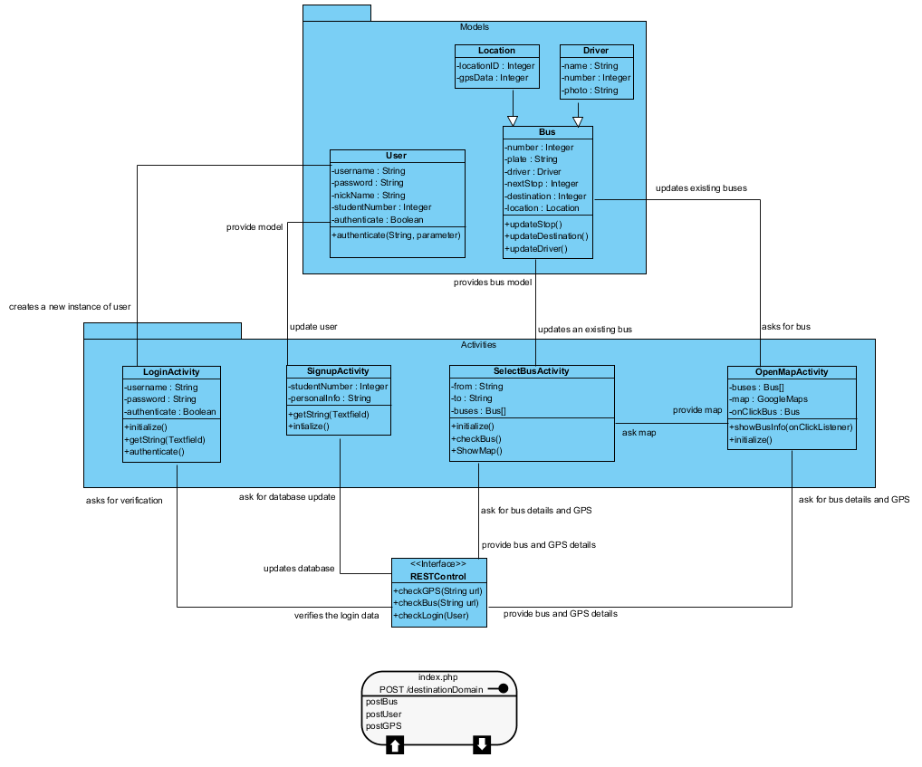

  - Sequence Diagrams
    - Show Busses On Map
Following sequence Diagram illustrates the scenario explained below:
Scenario: User Alice requests to see all the Rings’ whereabouts on map. To do that Alice clicks on “Show Rings on Map” button from SelectBusActivity. Then SelectBusActivity calls showMap() to trigger OpenMapActivity. After that OpenMapActivity, utilizing the RESTControl interface, calls checkBus() and checkGPS(). checkGPS() fetches the locations of the busses and checkBus() fetches the data of the busses (license plate, driver, where its heading…), the data is returned to SelectBusActivity. From that info, SelectBusActivity class updates the Busses. Then busses appear in the OpenMapActivity using the Google Maps plugin. If the user clicks on a certain bus then showBusInfo() is called and the bus info appears.
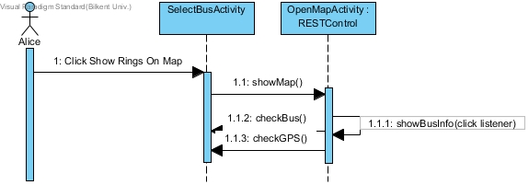

    - Tell When Nearest Bus Will Come
Following sequence Diagram illustrates the scenario explained below:
Scenario: User Alice requests to see when the next she wants to board Ring will come to her destination. Alice clicks on “Where is My Ring” button from SelectBusActivity. Then a new window in opens SelectBusActivity and she clicks on the location she is, out of five options (Main Campus, Tunus, Nizamiye, Sıhhiye, East Campus). What she selects is initialized as the variable “from”. Then she clicks on where she is heading out of the same options and that is initialized as the variable “to”. Then checkBus(), in accordance with the variables to and from, fetches the location of the nearest Ring and calculates when it will arrive to the bus stop from it’s speed. Lastly, SelectBusActivity displays when the bus will arrive to Alice’s destination.
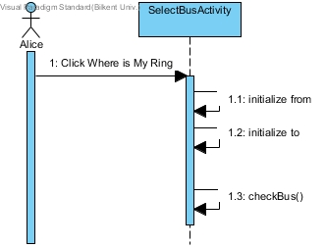

    - Login
Following sequence Diagram illustrates the scenario explained below:
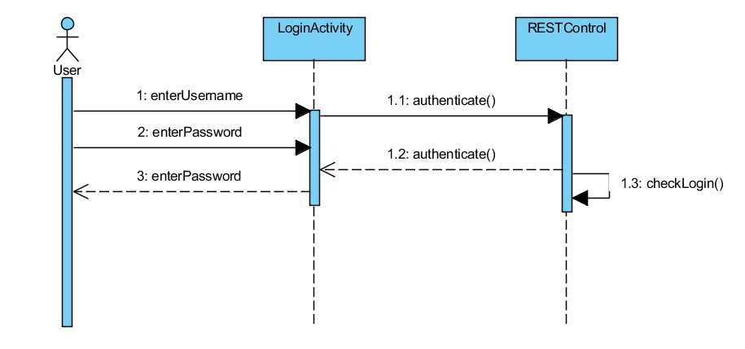
Scenario: The login information is gathered from a database that we are going to form with MySQL. Before the login phase, there should be signup phase for the new users. The access to our database is protected by standard http and the tools we use also gives us some extra functions for protection of data. So, our database will be secure enough against penetration or injections.

  - User Interface
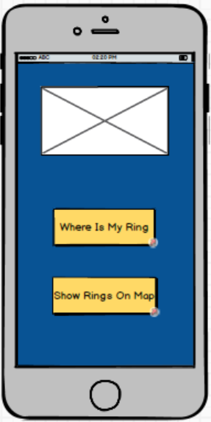

Home Page: This page has two options. If user presses “where is my ring” button program asks user where he is and where he wants to go, then shows the remaining time for his ring to come. If user presses “show rings on map” button program opens a map where all rings whereabouts are visible.

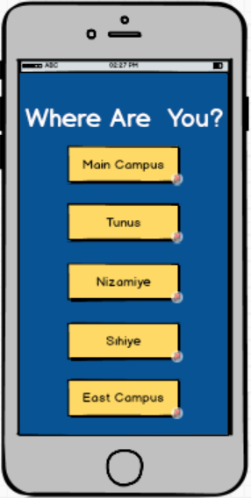

Where are you page: This page asks the user his whereabouts

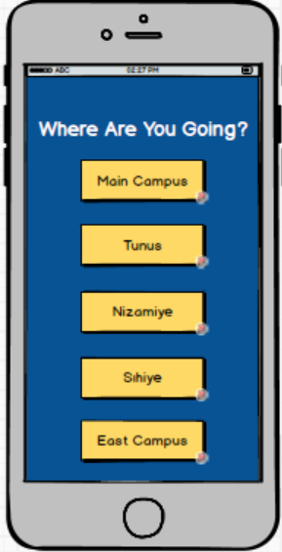

Where are you going page: This page ask user where he wants to go
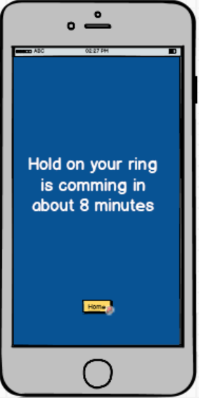

Report Page: After user chooses where he is and where he wants to go, program tells the user when the ring he need will come.

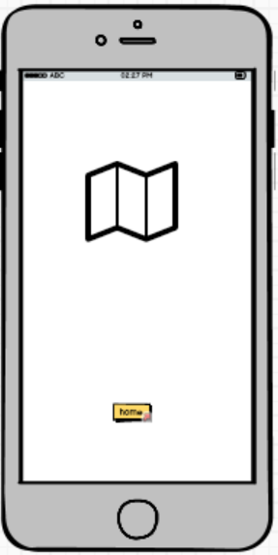

Map Page: This page show all rings on the map according to their whereabouts.

State Diagram of Pages:

